*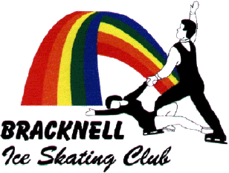The Junior Club Reps Winter Themed Party – Reply Slip*

*TUESDAY 18TH FEBRUARY 2014*

Please reserve me tickets for BISC Junior Club Reps party on 18th February 6-9pm

I enclose a cheque (please do not leave cash) made payable to ‘BISC’ for £5 per ticket.

Name: …………………………………………………………………………….

Name: …………………………………………………………………………….

Name: …………………………………………………………………………….

Note: All attendees must be BISC members

Total value of cheque…………………………………………………………………….

Name of parent/guardian……………………………………………………………….

Contact number for parent/guardian during party………………………………………………………….

Please put slip together with a cheque in an envelope marked ‘Junior Club Reps Party’ in the multi-coloured club box.

No paper tickets will be issued, but list of names will be on the door.

**Deadline for receiving reply slip and payment: Sunday 9th February 2014**