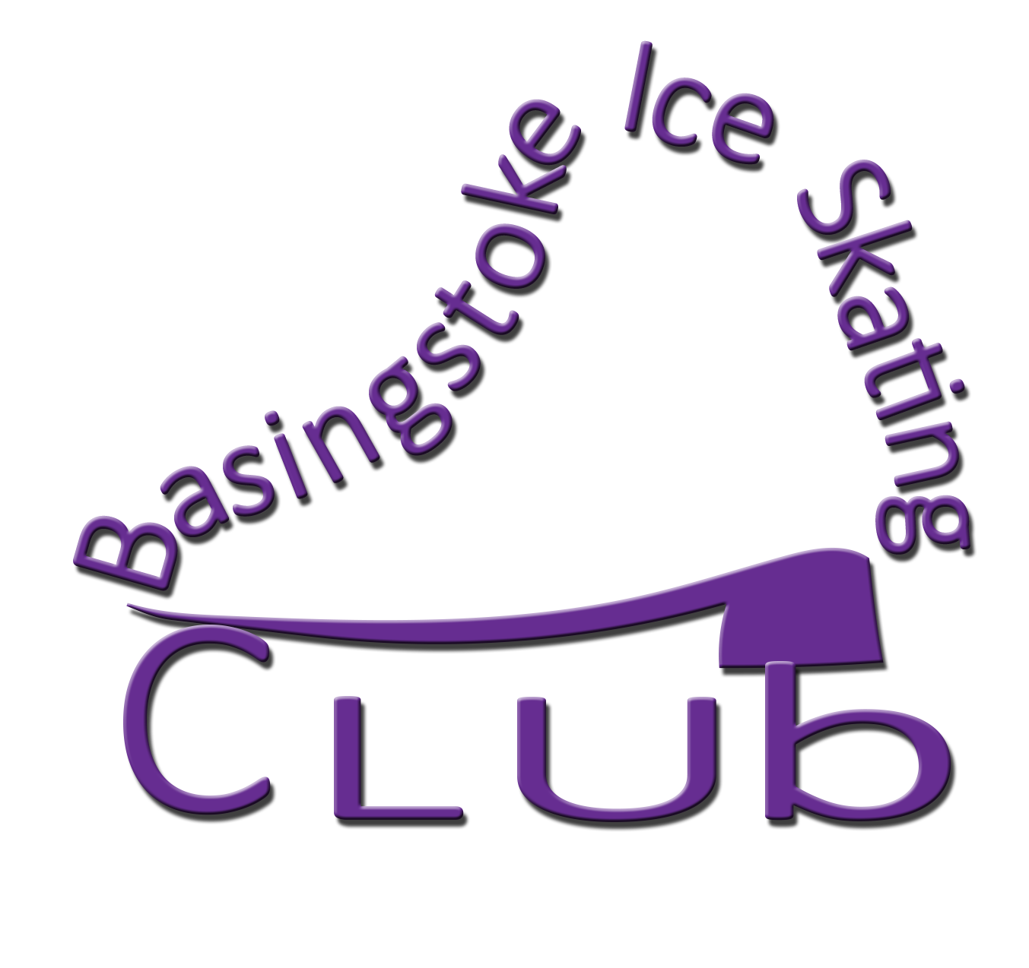

Dear Skaters, Parents, Coaches & Club Secretary,

Basingstoke Ice Skating Club’s Open Competition for Free Skating is being held on 3rd, 4th & 5th November 2014. This year our Open is being run using the International Judging System (IJS) for Beginners and above.

Please find attached the schedule & entry form. All skaters entering Level 1 & above are required to complete a programme content sheet using the correct ISU abbreviations as per ISU communication 1790, and must include the time of each element within their programme. This must be submitted with the entry form and fee to enable us to register your entry into our Open.

The NISA criteria attached is version 4 as posted by NISA on 19/8/14, and if there are any further amendments notified by NISA, these will apply to the criteria used during our Open, so please keep checking the NISA website for any changes.

Please do not send your entries by Royal Mail signed for, as this will delay your entry.

Should it become necessary to limit the number of Skaters in any Class, a waiting list will be kept. The date entry forms are received by us will be recorded on the form.

There will be no photography or videoing allowed at this event. There will however be an Official Photographer for you to purchase photographs from of you/your own child. DVD’s of each class will also be on sale at the Registration desk. Please ensure that you indicate on the entry form whether you agree to the skater having photographs & a video taken.

Should you have any queries please do not hesitate to contact Maureen Kershaw (Competition Secretary) by email mk.bisc.open@btinternet.com or by phone 01983 754132 (please leave a message).

We would be most grateful if Clubs would circulate the details to your Coaches and Skaters. Please note that the closing date is Monday 6th October 2014.

Address of Rink:-
Planet Ice Arena, Leisure Park, Worting Road, Basingstoke, Hants, RG22 6PG
Tel: 01256 355 266 Please contact the rink for availability & cost of patch ice.

Some places to stay:-

Premier Inn: – Basingstoke Central, Basingstoke Leisure, Worting Road, Basingstoke, Hants, RG22 6PG. Access from M3 J6 Tel: 0871 527 8062 Fax: 0871 527 8063

Premier Inn:- Basingstoke South, North Waltham, Nr. Basingstoke, Hants, RG25 2BB
7 Miles from Basingstoke Town Centre Tel: 0871 527 8064 Fax: 0871 527 8065

Travelodge: - Stag & Hounds, Winchester Road, Basingstoke, Hants, RG22 6HN
4 Miles from Basingstoke Train Station Tel: 0871 984 6009 Fax: 01256 843 566

Holiday Inn:- Grove Road, Basingstoke, RG21 3EE . Easy access from M3 East & West via Junction 6 Tel: 01256 310000 Fax: 01256 840081

We look forward to welcoming you all at our Open.

BASINGSTOKE ICE SKATING CLUB

