BASINGSTOKE ICE SKATING CLUB  OPEN COMPETITION – 15th, 16th and 17th AUGUST 2014 | 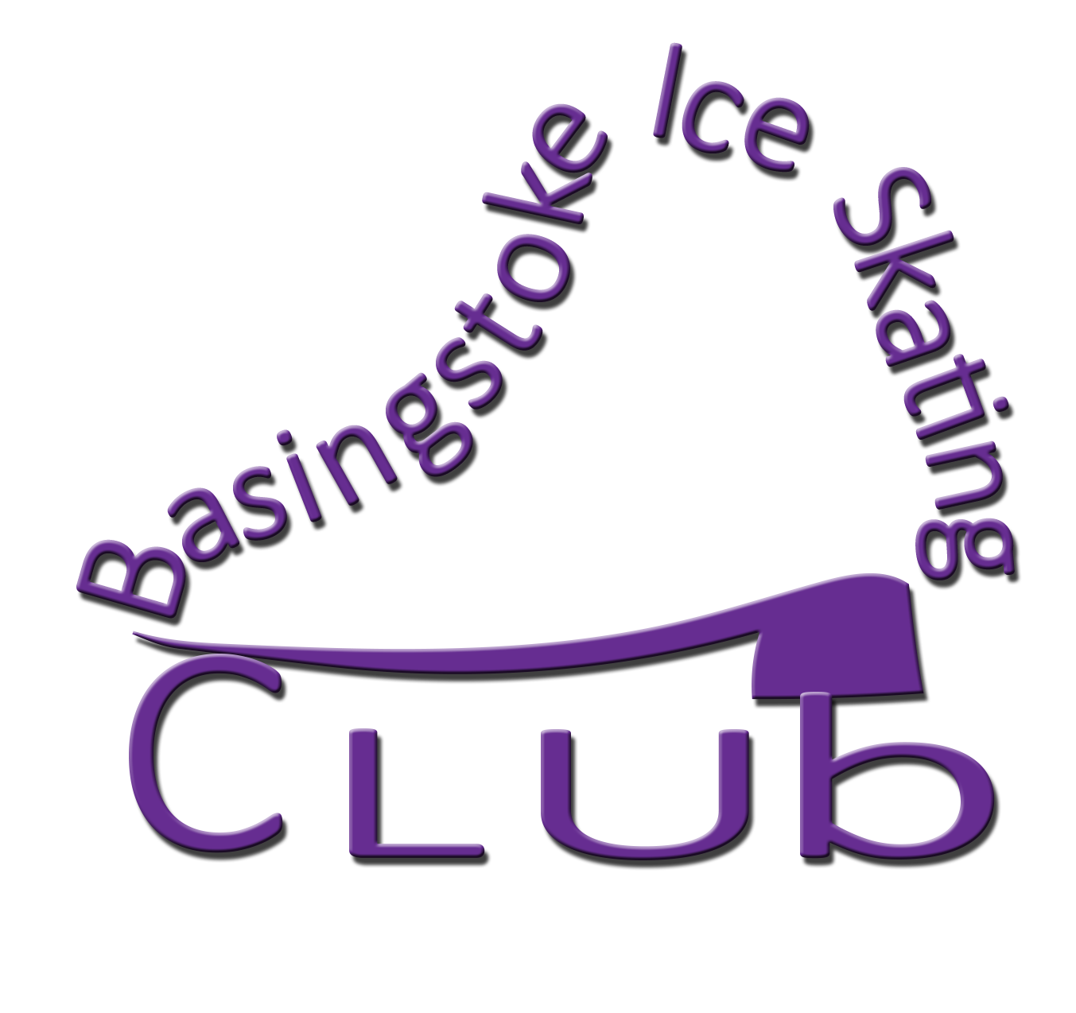

Programme Content Sheet

This form must be submitted with the entry form by 6th october 2014
Please fill in with type or write in capital letters. PLEASE USE THE OFFICIAL ELEMENT CODES. If not completed correctly the entire entry form will be returned without being registered and NOT ACCEPTED.
Competitor(s):
Category: Men Ladies
Event entered:
Rink/Club:

ELEMENTS IN ORDER OF SKATING

 | Time* | Programme Elements
1
2
3
4
5
6
7
8
9
10
11
12
13
14
15
16
* Time during program

Date, Signature:
Please include with your completed application entry form and fee to:-
Mrs. M. KERSHAW, 2, SEAVIEW COTTAGE, MONKS LANE, FRESHWATER, ISLE OF WIGHT, PO40 9SU

PLEASE NOTE: INCOMPLETE ENTRY FORMS WILL BE RETURNED AND THE WHOLE ENTRY FORM WILL BE REJECTED WITHOUT THE SKATER BEING REGISTERED FOR THE EVENT.

