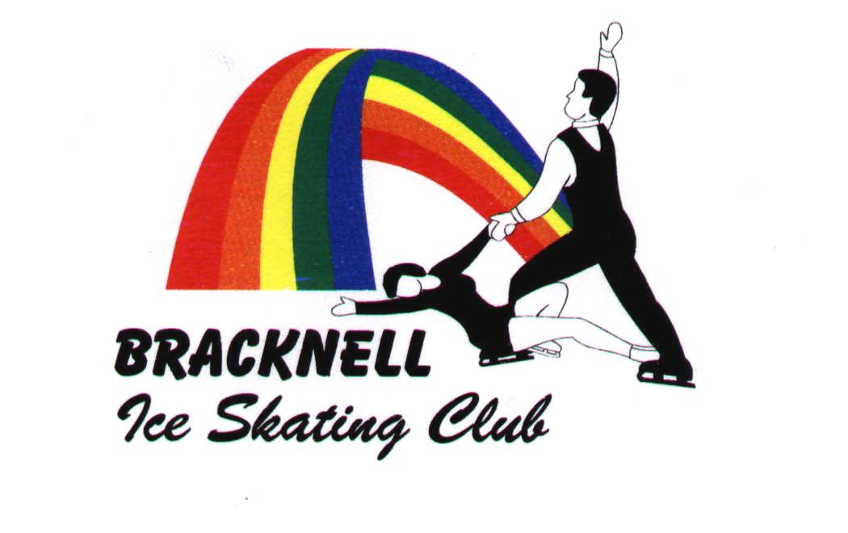
Held under NISA regulations and permit.

You must be a member of NISA

26th to 28th APRIL 2006
(Closing date Sat 1st April 2006)

Standard:
Under level 1 to level 10,
beginner couples/pairs to Pre NJS pairs,
single and group artistic.

John Nike Leisuresport Complex,
John Nike Way,
Bracknell, Berkshire.

9.3.06 version 1
If Classes 1 - 11 and 25 - 28 are over subscribed they will be split into age groupings
eg; class 2a - level 1 girls 10 and under, class 2b - level 1 girls 11 and over.

Event Number | Event level | Minimum Test Requirement |  | Maximum Test Requirement |  | Program Length | Notes
Class 1 | Beginner  Ladies or Men | Skate UK Gold Star (Figure) or Novice Field Moves or Level 1 Dance Moves |  | Must not hold any of the following:  - Level 1 Elements or  - Level 1 Free |  | 1½ Minutes (+/- 5 seconds) | Skaters must perform a well balanced programme comprising only single jumps.  No Axels are permitted  No combinations or sequences are permitted  Max 2 basic position spins with no change of foot and no change of position  A photocopy of the Skate UK passport must be submitted with the application form (unless Novice Field Moves or Level 1 Dance Moves already held)
Class 2 | Level 1  Ladies | Novice Field Moves or Level 1 Dance Moves and either  - Level 1 Elements or  - Level 1 Free |  | Must not hold any of the following:  - Level 2 Elements or  - Level 2 Free |  | 1½ Minutes (+/- 5 seconds) | Skaters must perform a well balanced programme comprising only single jumps.  No Axels are permitted  Only one jump combination or sequence is permitted.  Max 2 spins (1 may have a change of position)  One step sequence must be included
Class 3 | Level 1  Men
Class 4 | Level 2  Ladies | - Prelim Field Moves or Level 2 Dance Moves and either  - Level 2 Elements or  - Level 2 Free |  | Must not hold any of the following  - Level 3 Elements or  - Level 3 Free |  | 1½ Minutes (+/- 5 seconds) | Skaters must perform a well balanced programme comprising only single jumps.  No Axels are permitted  A maximum of 2 jump combinations and/or sequences are permitted  Max 2 spins (1 may have a change of position and 1 may have a change of foot)  One step sequence utilising the full ice surface must be included
Class 5 | Level 2  Men
Class 6 | Level 3  Ladies | Prelim Field Moves or Level 2 Dance Moves and either  - Level 3 Elements or  - Level 3 Free |  | Must not hold any of the following  - Level 4 elements or  - Level 4 Free |  | 1½ Minutes (+/- 5 seconds) | Skaters must perform a well balanced programme. No double jumps are permitted but single Axels can be included  A maximum of 2 jump combinations and/or sequences are permitted. – the Axel may not be attempted more than twice in the programme  Maximum 2 spins (1 may have a change of position and 1 may have a change of foot)  One step sequence utilising the full ice surface must be included
Class 7 | Level 3  Men
Class 8 | Level 4  Ladies | Inter Bronze Field Moves or Level 4 Dance Moves and either  - Level 4 Elements or  - Level 4 Free |  | Must not hold any of the following  - Level 5 Elements or  - Level 5 Free |  | 2 Minutes (+/- 5 seconds) | Skaters must perform a well balanced programme which includes a variety of jumps, spins and steps (from any level) but with:  - an Axel  - a maximum of 1 solo double jump  - a minimum of 1 and a maximum of 2 jump combinations/sequences (jumps may be different from the solo jumps)  - a maximum of 2 different spins (minimum of 3 revs in each or a minimum of 6 revs in total if a spin combination is performed)  - 1 step sequence, straight line, circular or serpentine  N.B. Both the Axel and each different double jump may only be attempted twice in the programme
Class 9 | Level 4  Men
Class 10 | Level 5  Ladies | Inter Bronze Field Moves or Level 4 Dance Moves and either  - Level 5 Elements or  - Level 5 Free |  | Must not hold  - Level 6 Elements or  - Level 6 Free |  | 2 Minutes (+/- 5 seconds) | Skaters must perform a well balanced programme which includes a variety of jumps, spins and steps (from any level) but with:  - an Axel  - a maximum of 1 solo double jump  - a minimum of 1 and a maximum of 2 jump combinations/sequences (jumps may be different from the solo jumps)  - maximum of 2 different spins (one must be a change of foot; minimum of 3 revs in each spin and a minimum of 8 revs in total in the change foot spin)  - 1 step sequence, straight line, circular or serpentine  N.B. Both the Axel and each different double jump may only be attempted twice in the programme
Class 11 | Level 5  Men
Class 12 | Level 6  Ladies | Bronze Field Moves or Level 6 Dance Moves and either  - Level 6 Elements or  - Level 6 Free |  | Must not hold  - Level 7 Elements or  - Level 7 Free or  - Any part of any Competitive Test |  | 2½ Minutes (+/- 10 seconds) | Skaters must perform a well balanced programme which includes a variety of jumps, spins and steps (from any level) but with:  - an Axel  - a maximum of 2 different solo double jumps  - a minimum of 1 and a maximum of 2 jump combinations/sequences (jumps may be different from the solo jumps)  - a maximum of 3 different spins (one must be a flying spin; minimum of 3 revs in each spin and a minimum of 8 revs in total if a spin combination is performed)  - 1 step sequence, fully utilising the ice surface  N.B. Both the Axel and each different double jump may only be attempted twice in the programme
Class 13 | Level 6  Men
Class 14 | Level 7  Ladies | Bronze Field Moves or Level 6 Dance Moves and either  - One part Level 7 or  - Pre-Novice Competitive Test |  | Must not hold  - Level 8 Elements or  - Level 8 Free or  - Any part of NISA Novice Competitive test or higher |  | 2½ Minutes (+/- 10 seconds) | Skaters must perform a well balanced programme which includes a variety of jumps, spins and steps (from any level) but with:  - a maximum of 2 different solo double jumps  - a minimum of 1 and a maximum of 2 jump combinations/sequences (jumps may be different from the solo jumps)  - a maximum of 3 different spins (min. of 5 revs in each or a min of 8 revs in total if a spin combination is performed)  - 1 step sequence, straight line, circular or serpentine, fully utilising the ice surface (this can be a spiral sequence)  N.B. Both the Axel and each different double jump may only be attempted twice in the programme
Class 15 | Level 7  Men
Class 16 | Level 8 Ladies | Inter-Silver Field Moves or Level 8 Dance Moves and either  - One part of Level 8 or  - 1 part of the NISA Novice Competitive Test |  | Must not hold  - Both parts of Level 9 or  - Both parts of NISA Primary (ISU Novice) Competitive Test or higher |  | Ladies 3 Minutes (+/- 10 seconds)  Men 3 ½ Minutes (+/- 10 seconds) | Skaters must perform a well balanced programme which includes a variety of good quality jumps, spins and steps (from any level) but also with:  - a minimum of 1 and a maximum of 3 jump combinations/sequences (jumps may be different from the solo jumps)  - a maximum of 3 different spins (one of which must be a flying spin with a min of 4 revs. Other spins must have a min of 5 revs or a min of 8 revs in total if a spin combination is performed)  - a maximum of 1 step or spiral sequence, fully utilising the ice surface  N.B. Only 2 different jumps with 2½ or 3 revs can be repeated and if so should be in either a jump combination or jump sequence. No jump of 2½ or 3 revs can be attempted more than twice.
Class 17 | Level 8 Men
Class 18 | Level 9 Ladies | Inter-Silver Field Moves or Level 8 Dance Moves and either :  - One part of Level 9 or  - 1 part of the NISA Primary (ISU  Novice) Competitive Test |  | Must not hold  - Both parts of Level 10 or  - Both parts of the Junior Competitive Test or higher |  | Ladies 3½ Minutes (+/- 10 seconds)  Men 4 Minutes (+/- 10 seconds) | Skaters must perform a well balanced programme which includes a variety of good quality jumps, spins and steps (from any level) but also with:  - a minimum of 1 and a maximum of 3 jump combinations/sequences (jumps may be different from the solo jumps)  - a maximum of 3 different spins (one of which must be a flying spin with a min of 5 revs. Other spins must have a min of 5 revs or a min of 10 revs in total if a spin combination is performed)  - a maximum of 2 step sequences for Ladies, one of which must be a spiral sequence, and a maximum of 2 different step sequences for men, fully utilising the ice surface  N.B. Only 2 different jumps with 3 revs or more can be repeated and if so should be in either a jump combination or jump sequence. No jump of 3 revs or more can be attempted more than twice.
Class 19 | Level 9 Men
Class 20 | Level 10 Ladies | Inter-Silver Field Moves or Level 8 Dance Moves and either  - One part of Level 10 or  - One part of the Junior Competitive Test |  | No maximum test requirement |  | Ladies: 4 Minutes (+/- 10 seconds)  Men: 4½ Minutes (+/- 10 seconds) | Skaters must perform a well balanced programme which includes a variety of good quality jumps, spins and steps (from any level) but also with:  - minimum of 1 and a maximum of 3 jump combinations/sequences (jumps may be different from the solo jumps)  - a maximum of 4 different spins (one of which must be a flying spin with a min of 6 revs or min of 10 revs in total if a spin combination is performed)  - a maximum of 2 step sequences for Ladies, one of which must be a spiral sequence, and a maximum of 2 different step sequences for men, fully utilising the ice surface  N.B. Only 2 different jumps with 3 or more revs can be repeated and if so should be in either a jump combination or jump sequence. No jump of 3 revs or more can be attempted more than twice.
Class 21 | Level 10 Men
Class 22 | Beginner Couples/Pairs | Each partner must have passed either Novice Field Moves or Level 1 Dance Moves | Must not hold any Pair Test or any part of Level 6 Figure or Dance Standard tests |  | Free Program of 2 minutes (+/- 5 seconds) |  | The programme must contain ONLY the following elements:  - mid-line step sequence utilising the full length of the ice surface.  - second step sequence (any pattern). This may include spirals  - pair spin/dance spin in any position and any hold (min. 2 revs). Change of foot or position optional  - side by side solo spin (min. 3 revs)  - Moves demonstrating quality edges, simple turns and footwork should be included  - at least 3 different dance/pair holds should be demonstrated throughout  - recognised pair/dance lifts are not allowed  - Vocal music is not permitted
Class 23 | Novice Pairs  (NISA Novice) | Novice Pair Test and  Prelim Field Moves or Level 2 Dance Moves with either  - Level 2 Elements or  - Level 2 Free | No Maximum Test Requirement |  | Free Program of 2½ minutes (+/- 10 seconds) |  | The well balanced programme must contain:  - minimum 2 lifts, maximum 3 (only one may be a twist lift – only single twist permitted. This complies with group 2). Lifts can only be selected from Groups 1 and 2. Platter lift not permitted  - only 1 throw jump (single or double)  - only 1 solo jump (single or double)  - minimum 1 pair spin (min. 3 revs in total), max 2: (second pair spin, if executed, need not comply with rev. requirements)  - only 1 solo spin (min. 3 revs in total)  - minimum 1 death spiral or pivot figure, max 2 (only 1 may be a death spiral)  - minimum 1 step or spiral sequence.
Class 24 | Pre NJS Pairs  (Preparing for ISU Novice Free) | Novice Pair Test and Inter Bronze Field Moves or Level 4 Dance Moves plus  - Level 4 Elements or  - Level 4 Free  OR 2006 NJS ENTRY  - Bronze Field Moves or Level 6 Dance Moves and  - Level 6 Elements and  - Level 6 Free | No Maximum Test Requirement |  | Free Program of 3 ½ minutes (+/- 10 seconds) |  | The well balanced programme must contain only the following elements:  - 2 different lifts (1 must be from Group 3 or 4  - 1 twist lift (single or double  - 1 or 2 throw jumps (single or double)  - 1 solo jump (single or double)  - 1 jump combination or sequence. The jump combination may consist of only 2 jumps. The jump sequence may consist of any number of jumps.  - 1 solo spin or solo spin combination (min. 5 revs in total)  - 1 pair spin or pair spin combination (min. 5 revs in total)  - 1 pivot figure without restrictions  1 step sequence which must fully utilise the ice surface

Event Number | Event Level | Minimum Test Requirement | Maximum Test Requirement | Program  Length | Notes
Class 25 | Level 1 and under  Artistic | Skate UK Gold Star (Figure) or Novice Field Moves or Level 1 Dance Moves | Must not hold any of the following  Level 2 Elements or  Level 2 Free | 2 Minutes +/- 5 seconds | Props can be used but they must be positioned only by the skater.  Vocal music may be used.  There will be five judges each marking an individual section.  Judge 1 Technical Merit  Judge 2 Artistic Impression  Judge 3 Musical Interpretation  Judge 4 Choreography  Judge 5 Costume/Props – note that it is the way that the costume and props are being used that is being judged here, rather than the actual costume/props themselves.  Each judge will also give a second mark for Entertainment value. Both sets of marks per judge will be added with the highest overall score being the winner. In the event of a tie, the Entertainment Value mark will be used as the tiebreaker.  No fireworks (or similar) are allowed  Small props means that each prop should be brought onto the ice by a single skater.  No intervention by a 3rd party (not on the ice) such as remote control or throwing on of props  Timing – only 30 secs max allowed between the skater’s name being called and the music starting.
Class 26 | Level 2/3  Artistic | Either Level 2 Elements or Free | Must not hold any of the following  Level 4 Elements or Level 4 Free | 2 minutes (+/-5 seconds)
Class 27 | Level 4/5 Artistic | Either Level 4 Elements or Free | Must not hold any of the following  Level 6 Elements or Level 6 Free | Up to 2 mins 40 secs
Class 28 | Level 6 and over Artistic | Either Level 6 Elements or Free | No maximum standard | Up to 2 mins 40 secs
Class 29 | Group artistic  of two to four persons | Skate UK Gold Star (Figure) or Novice Field Moves or Level 1 Dance Moves | No Maximum standard | 2 minutes 30 secs (+/-10 seconds)

If Classes 1 - 11 and 25 - 28 are over subscribed they will be split into age groupings
eg; class 2a - level 1 girls 10 and under, class 2b - level 1 girls 11 and over.
BRACKNELL OPEN FREE, ARTISTIC AND PAIR SKATING COMPETITIONS 2006
GENERAL NOTES
CLOSING DATE FOR ENTRIES Saturday 1st April 2006
The competitions will be held on Wednesday 26th to Friday 28th April 2006 at Bracknell Ice Rink
CLASSES 1 - 21 (SINGLES up to level 10) £18.00 per entry
CLASSES 22 - 24 (PAIRS) £20 per entry
CLASSES 25 - 28 (ARTISTIC) £18.00 per entry and
CLASS 29 (GROUP ARTISTIC) £20 per entry (not per person)

Rules
The competitions will be held under NISA regulations and are open to eligible members as defined by NISA
The Committee of Bracknell Ice Skating Club reserve the right to refuse entry without reason or to cancel a competition because of insufficient entries.
Sections of the non-championship competitions may be split further by age at the discretion of the club and referee
ONLY WRITTEN APPLICATIONS WILL BE ACCEPTED
Entries will not be accepted unless ALL NEW STANDARD AND COMPETITIVE levels with dates of test passes have been properly completed.
Test standards and age are as at closing date. (1st April 2006)
Entries may be limited determined by the time available and a reserve list will operate up until the draw.
The draw for competitions for classes 1- 21 and 25 to 28 will take place on Tuesday 25th April 2006 at Bracknell Ice Rink.
Music on cassette, mini disc or compact disc will be accepted. THESE SHOULD BE CLEARLY MARKED with name, address and class number and handed in at the club reception table on arrival. Only one track should be recorded.
Entry fees will not be refunded for withdrawals after the closing date.
Trophies must be signed for and held at the winner’s risk. They must be returned in good condition to the Trophy Secretary, Bracknell Ice Skating Club by the 1st March 2007 or on request.

Entry fees
Solo Skaters Classes 1 to 21 and 25 to 28 ALL - £18.00.
Classes 22 to 24 - £20 Per Pair or couple (not per person)
Class 29 2- 4 Group Artistic £20 per entry (not per person)
Please forward a separate cheque and entry form for each competition entered.
Cheques should be made payable to BRACKNELL ICE SKATING CLUB, with the name and competition on the back of the cheque.
Entries accompanied by a cheque that bounces will not be accepted until the entry fee is paid in cash together with an excess of £10 to cover any charges incurred

Please post entries to Sue Truby 58 Crowthorne Road, Sandhurst, Berks, GU47 9EP enclosing a STAMPED ADDRESSED ENVELOPE.
All queries to Sue Truby. 01252 879236 after 4.00 p.m. and before 9.30 p.m. there is an answerphone available
E mail competitions@bracknell-ice-skating-club.co.uk

