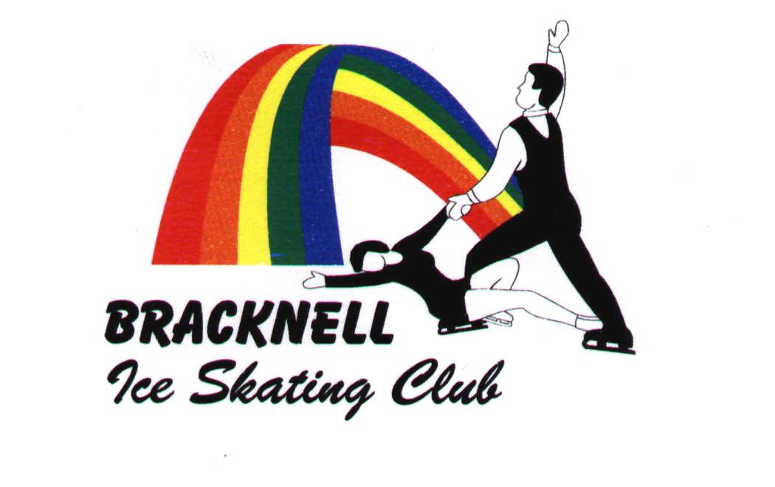

held under NISA regulations and permit.

You must be a member of NISA

24th and 25th APRIL 2006
(closing date Saturday 1st APRIL 2006)

John Nike Leisuresport Complex,
John Nike Way, Bracknell, Berkshire.

Solo Ice Dance Qualifying Competitions and
Non-Qualifying Open (solo and couples) Dance Competitions.

Version 1 7/3/06

Qualifying competitions for the British Solo Ice Dance Championships 2006.
British Solo Ice Dance qualifying competitions and championship test requirements required by the closing date of each event. Skaters must not have reached the age criteria shown below before 1st July 2006.

Entry is £30 per class

Comp  No | Level | Event name | Age | Minimum Test Requirement | Maximum Test Requirement | Compulsory dance | plus Original Dance
Class 1 | Novice | The Bracknell Solo Dance Cup | 12 | Level 1 Comp. Dance & Level 1 Variation Tests | N/A | Fiesta Tango  2 sequences | 1½ minutes +/- 10 seconds Charleston Rhythm tempo range 55-66 measures /minute (110-132 beats/minute)  See appendix for Required Elements
Class 2 | Primary | The Gladys Hooper Memorial Trophy | 14 | Level 3 Comp. Dance & Level 3 Variation Tests | N/A | 14 Step  2 sequences | 1½ minutes +/- 10 seconds March Rhythm tempo range 56-60 measures/minute (112 –120 beats/minute at 2/4 time)  See appendix for Required Elements
Class 3 | Junior | The Cover Homes Trophy | 16 | Level 5 Comp. Dance & Level 5 O.D. Tests | N/A | Blues  2 sequences | 2 minutes +/- 10 seconds Tango Rhythm  tempo range 24 – 35measures/minute  (96 – 140 beats/minute at 4/4 time of 4 beats per measure or 2/4 time of 2 beats per minute)  See appendix for Required Elements
Class 4 | Intermediate | The Lucine Chakmakjian Intermediate Solo Dance Trophy | 18 | Level 7 Comp. Dance & Level 7 O.D. Tests | N/A | Paso Doble  2 sequences | 2 minutes +/- 10 seconds Quickstep Rhythm  tempo range 50 – 60 measures/minute  (100 – 120 beats/minute at 2/4 time of 2 beats per measure)  See appendix for Required Elements
Class 5 | Senior | The David Phillips Senior Solo Dance Trophy | 25 | Part One of Level 9 Comp. Dance & Level 9 O.D. Tests | N/A | Argentine Tango  2 sequences | 2 minutes +/- 10 seconds Viennese Waltz Rhythm tempo range 52-60 measures of 3 beats per min. (156 – 180 beats/minute)  See appendix for Required Elements

Non-Qualifying Competitions.
Please note that there are no age restrictions on the following classes – this is to allow skaters who are not eligible for qualifiers to enter. If you are eligible (and entering) for qualifiers, then you should enter the appropriate non-qualifying class.

Please note that the following classes are not part of the qualifying rounds for the British Solo Dance Championships, and entry is £18 per class.

Class No. | Description | Event name | Standard | Programme length | Details
Class 6 | Solo Free Dance  (Novice) | The Sarah Louise Cup | No minimum standard  No maximum standard. | 1½ minute (+/- 10 secs) free dance | Required elements:  See Appendix – required elements are as for the Final of the British Championship Solo Ice Dance.
Class 7 | Solo Free Dance  (Primary) | The Roy Phillips Memorial Trophy | Minimum standard is Level 3 compulsory Ice Dance Test.  No maximum standard. | 1½ minute (+/- 10 secs) free dance | Required elements:  See Appendix – required elements are as for the Final of the British Championship Solo Ice Dance.
Class 8 | Solo Free Dance  (Junior) | The Marcin Glowacki Cup | Minimum standard is Level 5 compulsory Ice Dance Test.  No maximum standard. | 2 minute (+/- 10 secs) free dance | Required elements:  See Appendix – required elements are as for the Final of the British Championship Solo Ice Dance.
Class 9 | SoloFree Dance (Intermediate and Senior) | The Lynn Burton Trophy | Minimum standard is Level 7 compulsory Ice Dance Test.  No maximum standard. | 2 minute (+/- 10 secs) free dance | Required elements:  See Appendix – required elements are as for the Final of the British Championship Solo Ice Dance.

Please note that the following classes are not part of the qualifying rounds for the British Solo Dance Championships, and entry is £18 per class
apart from classes 18 and 20 (drawn partners) where the on-the-day entry fee is £5.
Class No. | Description | Minimum standard | Maximum standard | Programme length | Details
10 | Level 2 and under compulsories | no minimum standard | No higher than Level 2 compulsory dance test may be held | Solo dance | 2 dances to be skated.  Rhythm Blues and Dutch Waltz (2 sequences of each).
11 | Level 2 and under variation | no minimum standard | No higher than Level 2 variation dance test may be held | Variation dance | Competitors will be required to skate a Canasta Tango variation – See NISA publication “Ice Dances” Edition 13 – music 8-12 bars, Skaters commence with the prescribed steps for the Canasta Tango, interrupt the sequence at any one point, and insert dance steps of their own choice. Having executed this variation, the skater must return to the exact point of interruption and continue with the next step of the Canasta Tango to complete the sequence. The whole sequence, plus the variation, must then be repeated once. It is advisable to attempt to restart the sequence on the pattern of the Canasta Tango.
12 | Level 4 and under compulsories | no minimum standard | No higher than Level 4 compulsory dance test may be held | Solo dance | 2 dances to be skated.  Golden Skaters Waltz and Fiesta Tango (2 sequences of each).
13 | Level 4 and under original dance | no minimum standard | No higher than Level 4 original dance test may be held | Original dance 1½ minutes +/- 10 seconds | Competitors will be required to skate an original dance programme to any rhythm  The pattern of the dance must proceed in a generally constant direction, either clockwise or anti-clockwise and must not cross the long axis of the ice surface, except once at each end of the rink (within no more than 20 metres of the end barriers). Loops in either direction are permitted provided they do not cross the centre line. The mark for presentation determines ties. Vocal music is permitted, but skaters are advised to ensure that they skate to the underlying beat and not only to the melody.
14 | Level 7 and under compulsories | no minimum standard | No higher than Level 7 compulsory dance test may be held | Solo dance | 2 dances to be skated.  Foxtrot and 22 step (2 sequences of each).
15 | Level 7 and under original dance | no minimum standard | No higher than Level 7 original dance test may be held | Original dance 1½ minutes +/- 10 seconds | Competitors will be required to skate an original dance programme to any rhythm  The pattern of the dance must proceed in a generally constant direction, either clockwise or anti-clockwise and must not cross the long axis of the ice surface, except once at each end of the rink (within no more than 20 metres of the end barriers). Loops in either direction are permitted provided they do not cross the centre line. The mark for presentation determines ties. Vocal music is permitted, but skaters are advised to ensure that they skate to the underlying beat and not only to the melody.
16 | Open standard, compulsories | no minimum standard | no maximum standard | Solo dance | 2 dances to be skated.  Tango and Kilian (2 sequences of Tango, 3 sequences of Kilian).
17 | Open standard original dance | no minimum standard | no maximum standard | Original dance 2 minutes +/- 10 seconds | Competitors will be required to skate an original dance programme to any rhythm  The pattern of the dance must proceed in a generally constant direction, either clockwise or anti-clockwise and must not cross the long axis of the ice surface, except once at each end of the rink (within no more than 20 metres of the end barriers). Loops in either direction are permitted provided they do not cross the centre line. The mark for presentation determines ties. Vocal music is permitted, but skaters are advised to ensure that they skate to the underlying beat and not only to the melody.
18 | Drawn partners  (Monday) | no minimum standard | no maximum standard | couples compulsory dance | Competitors will be drawn on the day and the dance to be skated will be the Rhythm Blues with entry payable on the day at the club reception table.
19 | Couples – Novice | no minimum standard | no couples competitive test above Novice may be held | couples compulsory dance | 2 dances to be skated:  Foxtrot (4 sequences) and American Waltz (2 sequences)
20 | Drawn partners  (Tuesday) | no minimum standard | no maximum standard | couples compulsory dance | Competitors will be drawn on the day and the dance to be skated will be the Fiesta Tango with entry payable on the day at the club reception table.
Where two compulsory dances are skated, the one underlined above will be the tie-breaker.
BRACKNELL 2006 Solo Dance Qualifier and non-qualifying Open Dance competition

GENERAL NOTES
CLOSING DATE FOR ENTRIES Saturday 1st APRIL 2006

The competitions will be held on Monday 24th and Tuesday 25th April 2006 at Bracknell Ice Rink

- Rules
- The competitions will be held under NISA regulations and are open to eligible members as defined by NISA
- The Committee of Bracknell Ice Skating Club reserve the right to refuse entry without reason or to cancel a competition or combine classes because of insufficient entries.
- ONLY WRITTEN APPLICATIONS WILL BE ACCEPTED. Photocopies of entry forms will be accepted.
- Applicants wishing to receive proof of receipt should enclose a second stamped envelope.
- Entries will not be accepted unless ALL NEW STANDARD levels with dates of test passes have been properly completed.
- Ages are as at 1st July 2006.
- Test standards are as at 25th March 2006 – closing date.
- The draw for competitions (and couples compulsory dances) will take place at Bracknell on Sunday 23rd April 2006.
- Music on cassette, mini disc or compact disc will be accepted. THESE SHOULD BE CLEARLY MARKED with name, address and competition and handed in at the club reception table on arrival. Cassettes should be clearly marked with which side is to be played and wound back to the beginning. For any medium, there should be just one track recorded.
- Entry fees will not be refunded for withdrawals after the closing date.
- Trophies must be signed for and held at the winner’s risk. They must be returned in good condition to the Trophy Secretary, Bracknell Ice Skating Club by the 1st March 2007 or on request.
- Flash photography will not be permitted during warm-ups or competitions, either on the ice or at the rink side.
- Video photography is allowed with the prior permission of the skaters concerned.

- Entries
- Please forward a separate cheque and entry form for each competition entered.
- Cheques should be made payable to BRACKNELL ICE SKATING CLUB, with the name and competition number on the back of the cheque. Entries accompanied by a cheque that bounces will not be accepted until the entry fee is paid in cash together with an excess of £10 to cover any charges incurred
- Please post entries to Sue Truby 58 Crowthorne Road, Sandhurst, Berks GU47 9EP enclosing a STAMPED ADDRESSED ENVELOPE.

- all queries to Sue Truby. 01252 879236 after 4.00 p.m. and before 9.30 p.m. there is an answerphone available
- email competitions@bracknell-ice-skating-club.co.uk

BRITISH CHAMPIONSHIP FOR SOLO ICE DANCE APPENDIX

ORIGINAL DANCE ALL STANDARDS REQUIRED ELEMENTS.

- One mid-line step sequence skated along the full length barrier to barrier of the centre (long) axis of the rink must be included.
- One spin only must be included. Minimum 3 revolutions on one foot before any change of foot.
- Twizzles Novice and Primary in addition to any that may be skated during the step sequence: one clockwise, one anti clockwise minimum one (1) continuous rotation – not 3’s must be included. Junior, Intermediate and Senior in addition to any that may be skated during the step sequence minimum two (2) continuous rotations on each foot - not 3’s must be included. It should be noted that the end of the first twizzle should be controlled and checked, enabling the second twizzle to be executed on the same axis, with no more than 3 steps between the two twizzles.

Except during the step sequence, the pattern of the dance must proceed in a generally constant direction, either clockwise or anti clockwise and must not cross the long axis of the ice surface except once at each end of the rink (within no more than 20 metres of the end barriers). Loops in either direction are permitted provided they do not cross the centre line. A modest infringement of the centre regulation will be allowed only on rinks which are less than standard (60m x 30m) size.

FREE DANCE REQUIRED ELEMENTS.

NOVICE AND PRIMARY

- One diagonal step sequence skated fully corner to corner must be included.
- One spin only must be included. Minimum 3 revolutions on one foot before any change of foot.
- Twizzles in addition to any that may be skated during the step sequence one clockwise, one anti clockwise minimum one (1) continuous rotation not 3’s must be included. The two twizzles must be executed consecutively. It should be noted that the end of the first twizzle should be controlled and checked enabling the second twizzle to be executed on the same axis, with no more than 3 steps between the two twizzles.

JUNIOR, INTERMEDIATE AND SENIOR

1.One Serpentine anti-clockwise step sequence Commencing in an anti-clockwise direction at the centre (long) axis at one end of the rink and progressing in three bold
curves ( 2 in anti clockwise and 1 in clockwise direction ) and ending at the centre (long) axis of the opposite end of the rink ; pattern using the full width of the ice surface must be included. (Reference ISU Communication No 1318 Pg 13 )
2. Two spins only must be included. Minimum 3 revolutions on one foot before any change of foot.
3. Twizzles in addition to any that may be skated during the step sequence: one clockwise, one anti clockwise minimum two (2) continuous rotations on each foot – not 3’s must be included. The two twizzles should be executed consecutively. It should be noted that the end of the first twizzle should be controlled and checked enabling the second twizzle to be executed on the same axis, with no more than 3 steps between the two twizzles.

Jumps, dance spins, stops and pirouettes are not allowed during the step sequence.

TWIZZLES - See ISU Special Regulations Ice Dancing 2002 Rule N0 504, 14 (a) page 11

N.B. ORIGINAL DANCE & FREE

1. The twizzle sequence should be clearly defined as a required element in both the Original Dance and Free Dance. The inclusion of an excessive number of twizzles will affect the balance of a programme and could lead to deductions.

2. Should include interpretive steps, hops and jumps of no more than half a revolution. Emphasis to be placed on footwork which could incorporate movements selected freely from Dance Moves. Free Dance whilst there are no restrictions on the number of half revolution jumps, skaters may also include one jump of no more than one revolution.

FREE DANCE MUSIC:- As per ISU Regulations can contain vocals. It is important that skaters have a spare copy of music readily available at all events
ORIGINAL DANCE MUSIC:- As per ISU Regulations vocal music is permitted but skaters are advised to ensure they skate to the underlying beat and not only to the melody.

GENERAL : QUALIFYING ROUNDS

- The THREE* highest placed female competitors will qualify for the National Final if they enter further events the next highest placed will qualify.
- Males must enter a minimum of two events to qualify, but are advised to enter more.
- Should there be an over subscription requiring further limit on the number of entries, competitors who have previously qualified in another competition will be asked to withdraw their entries. This will allow those who have not yet qualified the best opportunity to compete. Should further restriction on numbers be required after taking this step, a draw will be held.
- A Skater wishing to enter more than one section will be asked to state their preference. In the event of numbers being restricted, competitors may only be allowed to enter their preferred category.

* Seven Solo qualifying competitions will be held in 2006 commencing in February
NB Following a review of the changes made in 2006 consideration will be given to the introduction of the appropriate Free Dance test levels for 2007.

FINAL

1. Qualifiers who have qualified for more than one category will only be allowed to compete in one.

WARM UPS QUALIFYING ROUNDS AND FINAL

Warm ups will be 3 minutes for all sections and warm up groups in all sections may number a maximum of 8 at the discretion of the Referee.

FACTORS:- Compulsory Dance 0.4 The mark for TECHNIQUE determines ties ( ISU Special Regulations Ice Dancing 2002 Rule no 544 para 3a )
Original Dance 0.6 The mark for PRESENTATION determines ties ( ISU rule no 544 para 3b )
Free Dance 0.6 The mark for PRESENTATION determines ties ( Rule no 544 para 3b )

NB. The Relative 6.0 scoring system will be used for all Solo events in 2006

